
Monday Activity Schedule
- Check It Off When Completed | Activity
 | Morning Work
 | Reading Comprehension Worksheet
 | Independent reading 20 minutes
 | Book Story Map
 | 25 minutes of Lexia or RazKids
 | Math Worksheet
 | 30 minutes of SplashMath or Zearn
 | Skills Worksheet
 | *Choice activity time: pick an activity from the ClassDojo class story (watch a read aloud, try a learning website, or reading journal entry) or independent read for 20 minutes

Morning Work- Monday
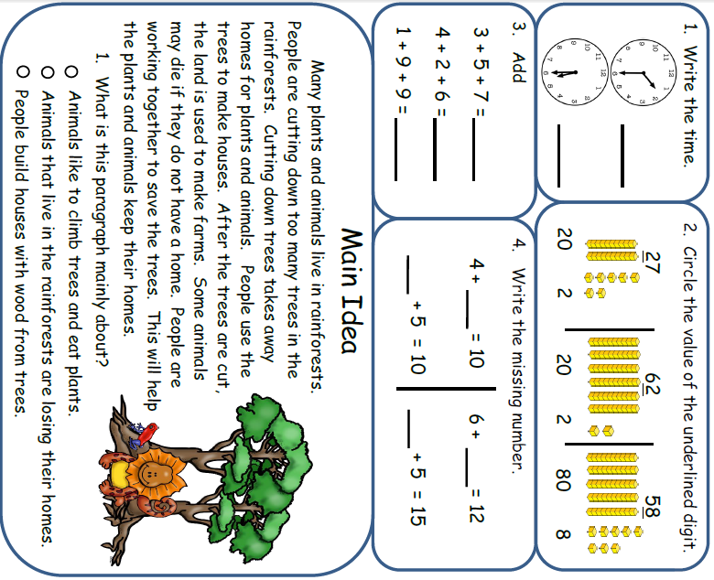

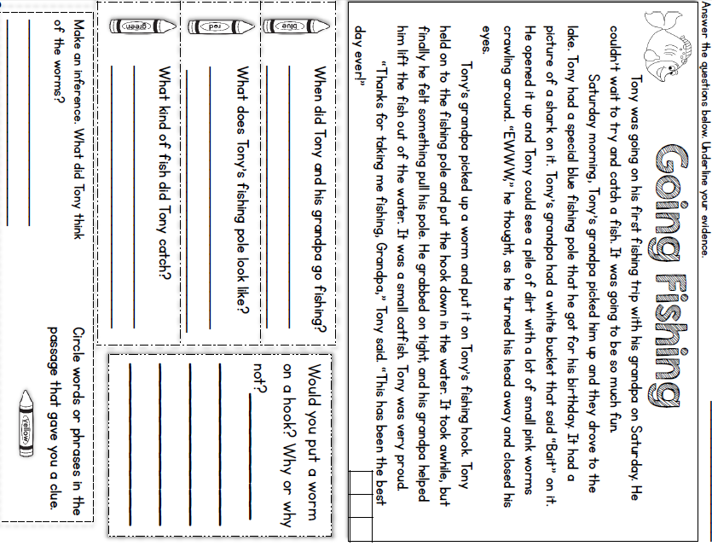
Monday- Reading

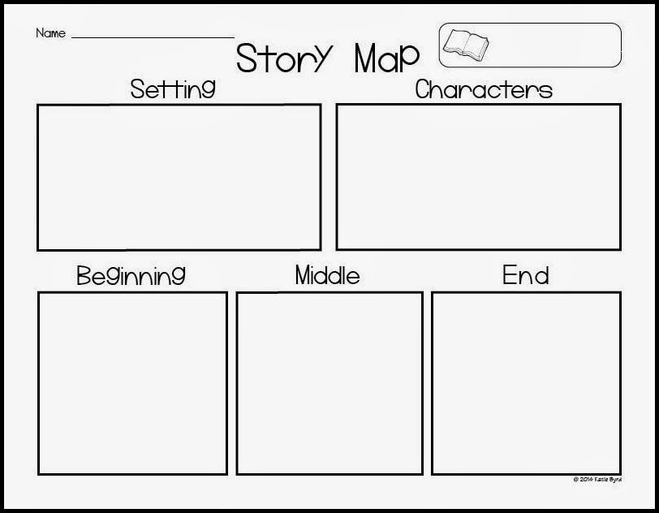
* Read a book and complete this story map.****
Monday- Reading
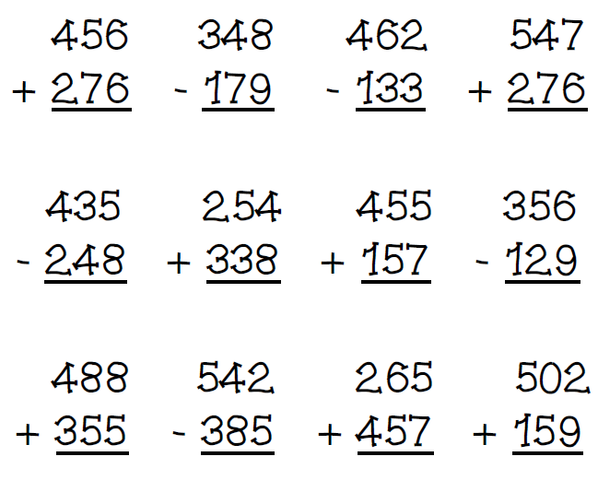
Monday- Math
Mondo needed to make 700 cupcakes for his school bake sale. On Monday he made 151 and on Tuesday he made 100 cupcakes. How many cupcakes does he have left to make?
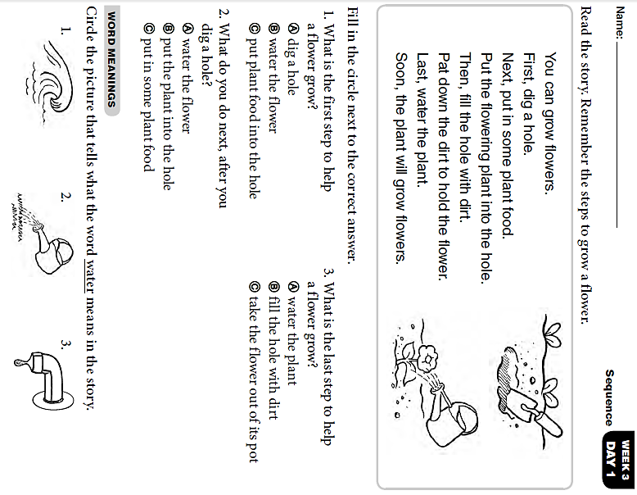
Monday- Skills
Tuesday Activity Schedule
- Check It Off When Completed | Activity
 | Morning Work
 | Writing a story Worksheet
 | Reading Comprehension
 | Independent reading 20 minutes & Book Story Map
 | 25 minutes of Lexia or RazKids
 | Math Worksheet
 | 30 minutes of SplashMath or Zearn
 | Skills Worksheet
 | *Choice activity time: pick an activity from the ClassDojo class story (watch a read aloud, try a learning website, or reading journal entry) or independent read for 20 minutes

Words to use:
- polar bear
- train
- ride
- people

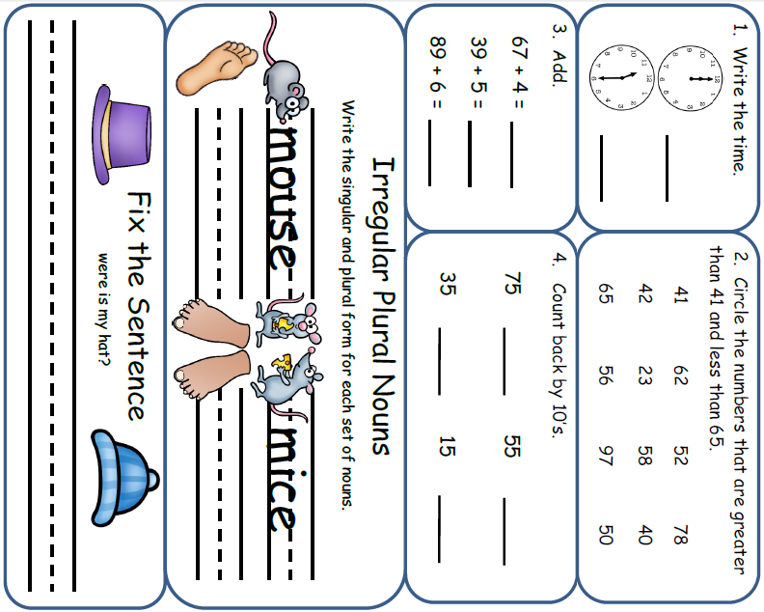
____________________________________________________________________________________________________________________________________________________________________________________________________________________________________________________________________________________________________________________________________________________________________________________________________________________________________________________________________________________________________________________________________
__________________________________________
Morning Work- Tuesday

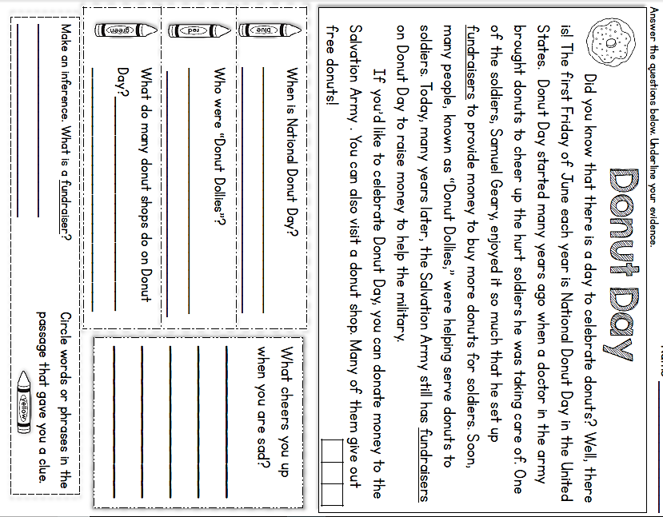
Tuesday- Reading

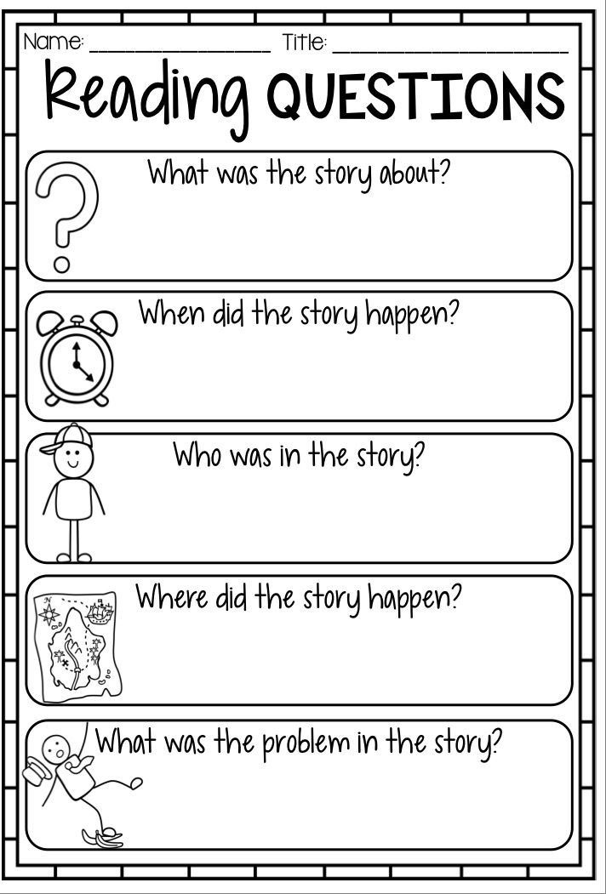
Read a book and complete this story map
Tuesday- Reading

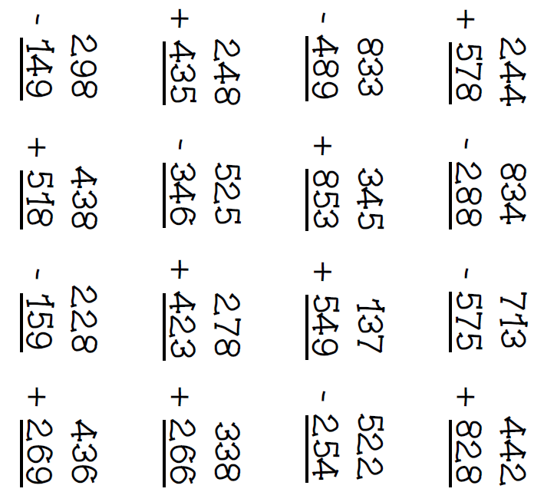
Tuesday- Math
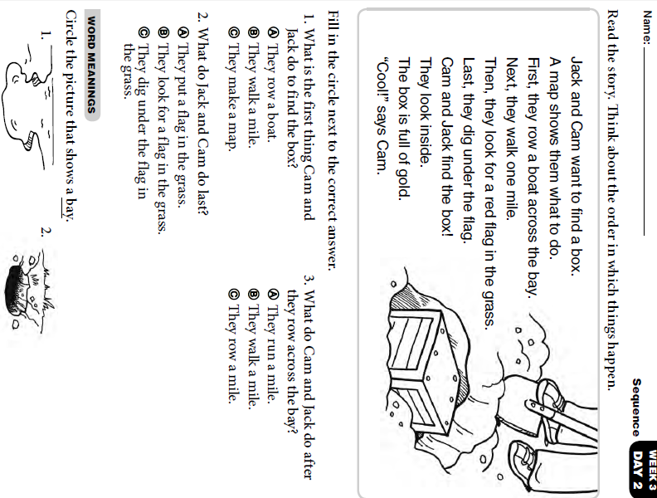
Tuesday- Skills


Wednesday Activity Schedule
- Check It Off When Completed | Activity
 | Morning Work
 | Writing a story
 | Independent Reading 20 minutes
 | Reading Comprehension Worksheet
 | 40 minutes of Lexia or RazKids
 | Math Worksheet
 | 40 minutes of SplashMath or Zearn
 | Skills Worksheet
 | *Choice activity time: pick an activity from the ClassDojo class story (watch a read aloud, try a learning website, or reading journal entry) or independent read for 20 minutes

Words to use:
- cowboy
- cat
- horse
- giant

_______________________________________________________________________________________________________________________________________________________________________________________________________________________________________________________________________________________________________________________________________________________________________________________________________________________________________________________________________________________________________________________________________________________________________________
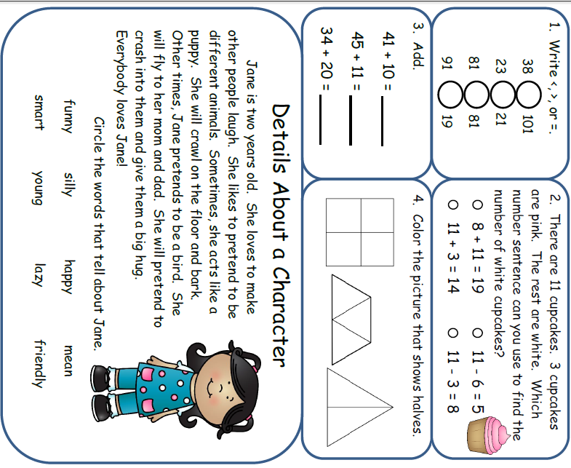
Morning Work- Wednesday

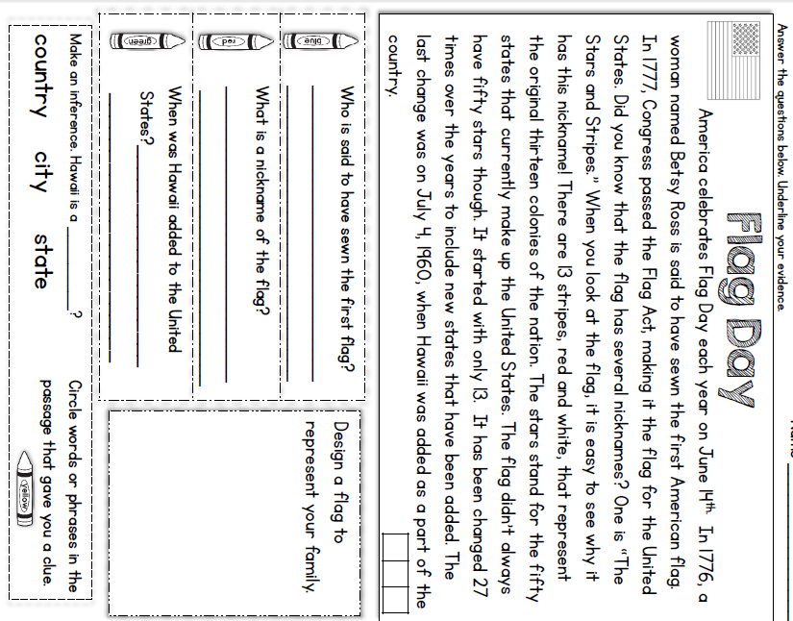
Wednesday - Reading

Sadie read 36 books on Monday and 45 books on Tuesday. On Wednesday she read the same number of books as she did on Monday. How many books did she read altogether?
Wednesday- Math

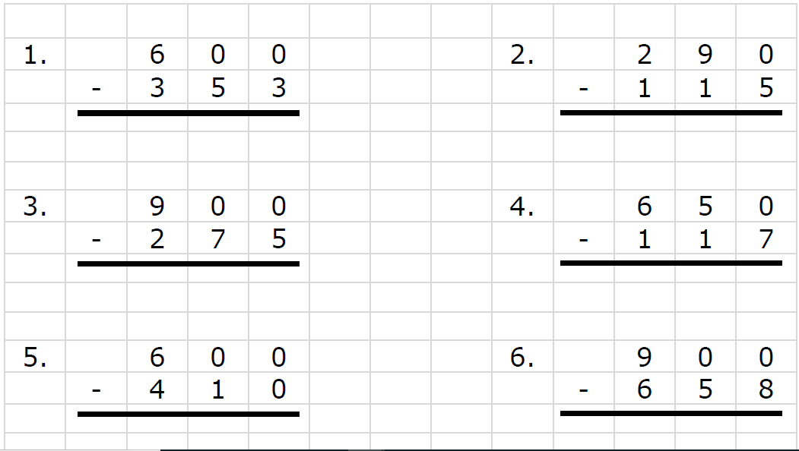
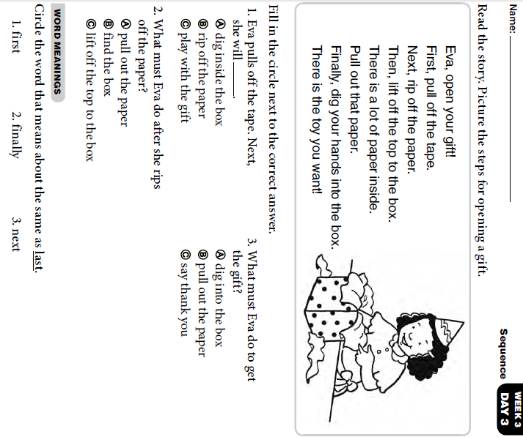
Wednesday- Skills


Thursday Activity Schedule
- Check It Off When Completed | Activity
 | Morning Work
 | Reading Comprehension Worksheet
 | Independent Reading 20 Minutes
 | Book story map
 | 30 minutes of Lexia or RazKids
 | Math Worksheet
 | 30 minutes of SplashMath or Zearn
 | Skills Worksheet
 | *Choice activity time: pick an activity from the ClassDojo class story (watch a read aloud, try a learning website, or reading journal entry) or independent read for 20 minutes

Morning Work- Thursday

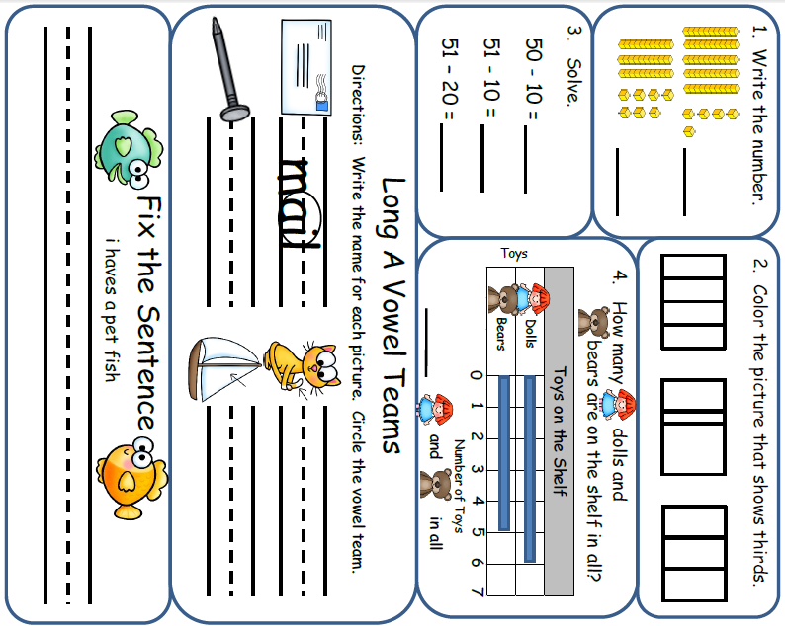

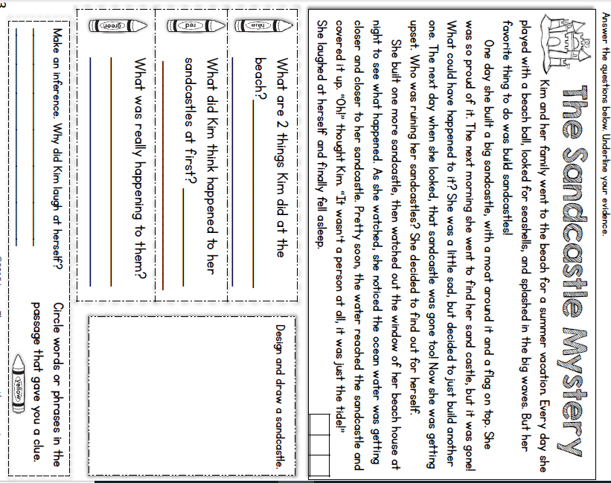
Thursday- Reading

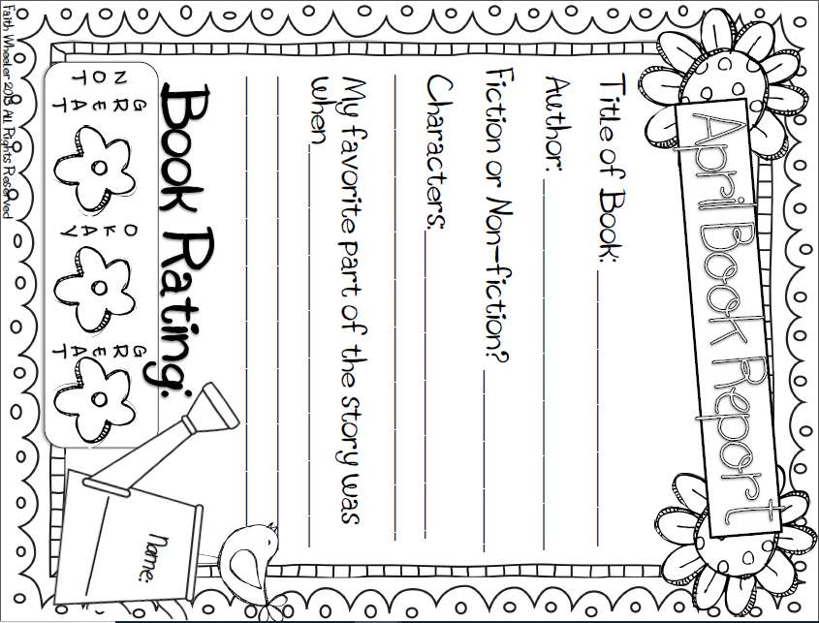

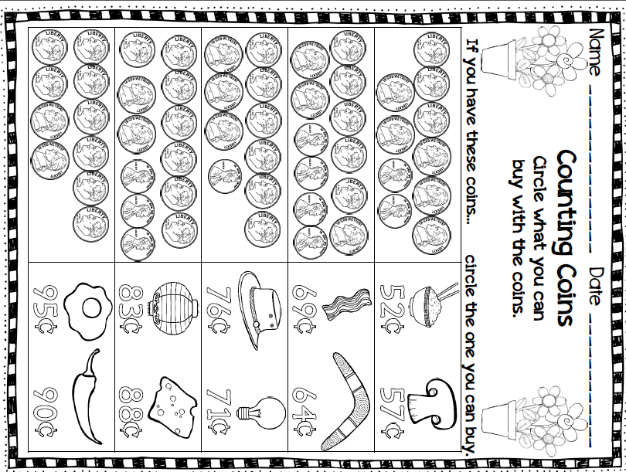
Thursday- Math

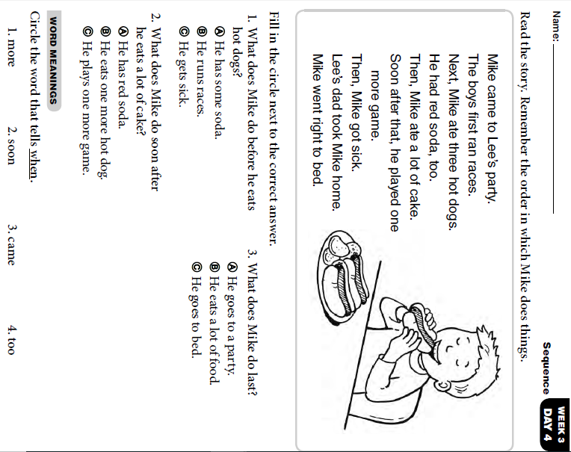
Thursday Skills



Friday Activity Schedule
- Check It Off When Completed | Activity
 | Morning Work
 | Writing a story
 | Independent reading 20 minutes
 | Reading Comprehension page
 | 40 minutes of Lexia or RazKids
 | Math Worksheet
 | 40 minutes of SplashMath or Zearn
 | Skills Worksheet
 | *Choice activity time: pick an activity from the ClassDojo class story (watch a read aloud, try a learning website, or reading journal entry) or independent read for 20 minutes


___________________________
Words to use:
- chef
- cooking
- apron
- dinner

_______________________________________________________________________________________________________________________________________________________________________________________________________________________________________________________________________________________________________________________________________________________________________________________________________________________________________________________________________________________________________________________________________________________________________________
Morning Work- Friday
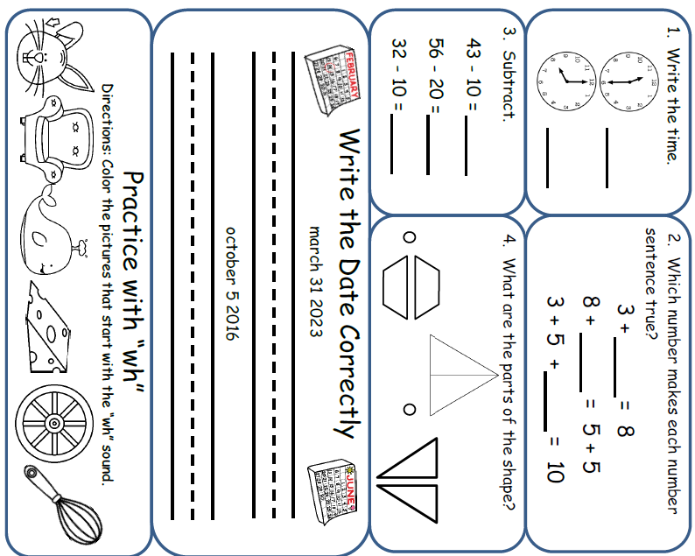

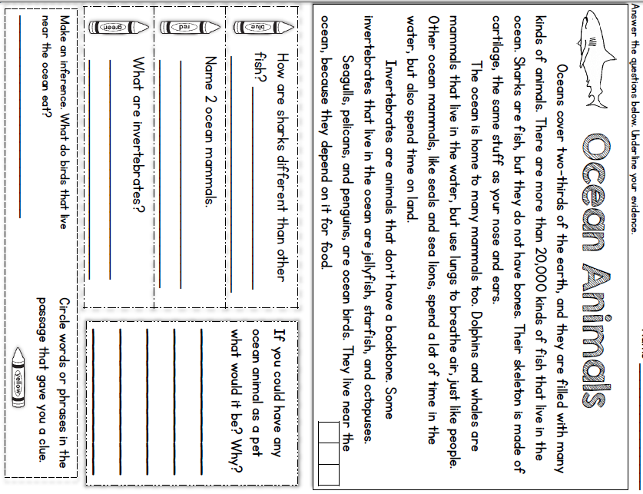
Friday Reading

Friday Math

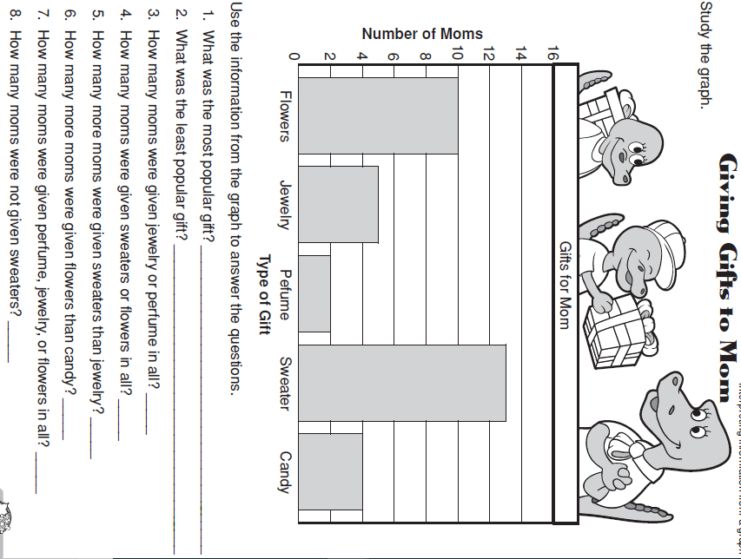

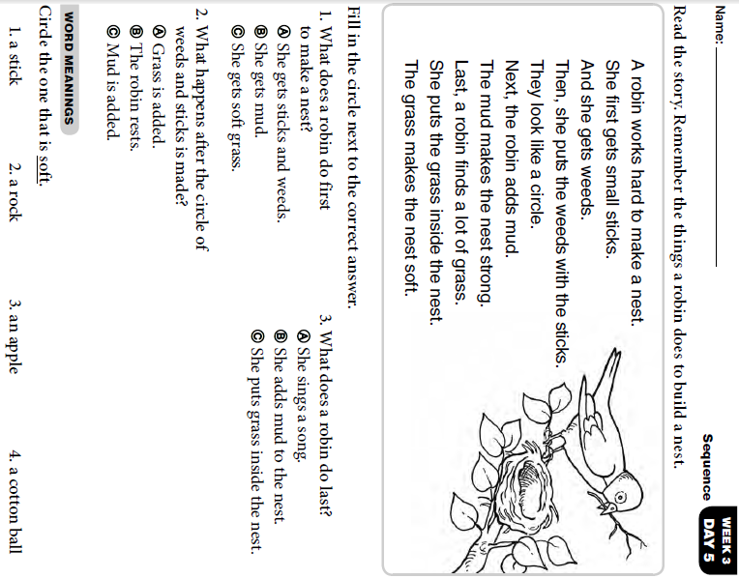
Friday Skills

Monday Activity Schedule
- Check It Off When Completed | Activity
 | Morning Work
 | Reading Comprehension Worksheet
 | Independent reading 20 minutes
 | Book Story Map
 | 25 minutes of Lexia or RazKids
 | Math Worksheet
 | 30 minutes of SplashMath or Zearn
 | Skills Worksheet
 | *Choice activity time: pick an activity from the ClassDojo class story (watch a read aloud, try a learning website, or reading journal entry) or independent read for 20 minutes

Morning Work- Monday

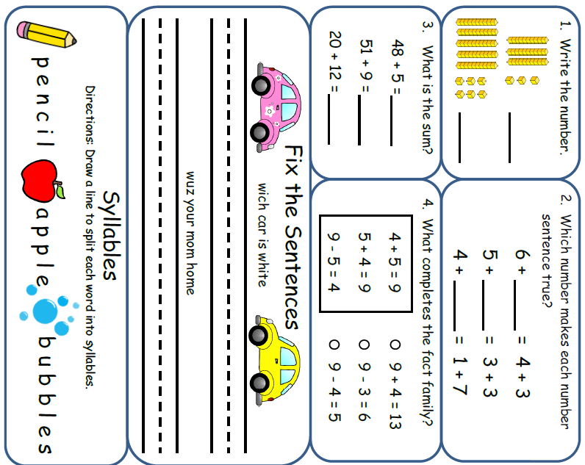
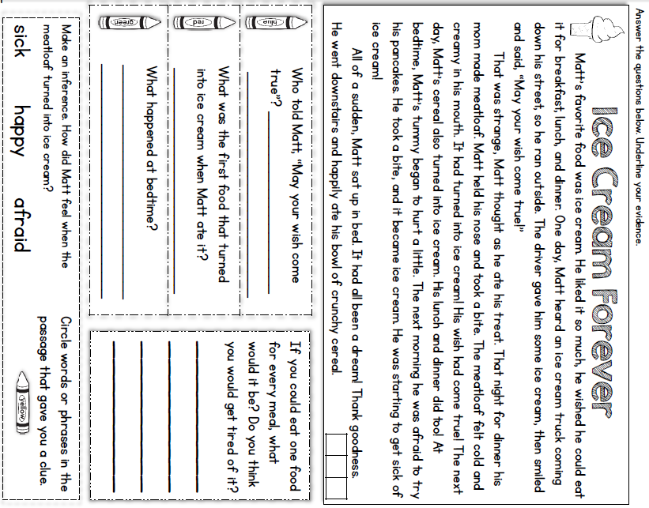
Monday- Reading
* Read a book and complete this story map.****
Monday- Reading
Monday- Math
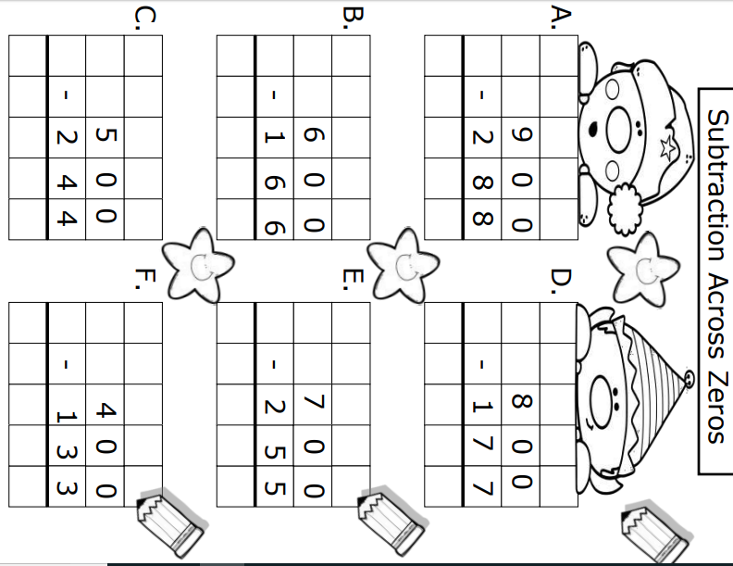
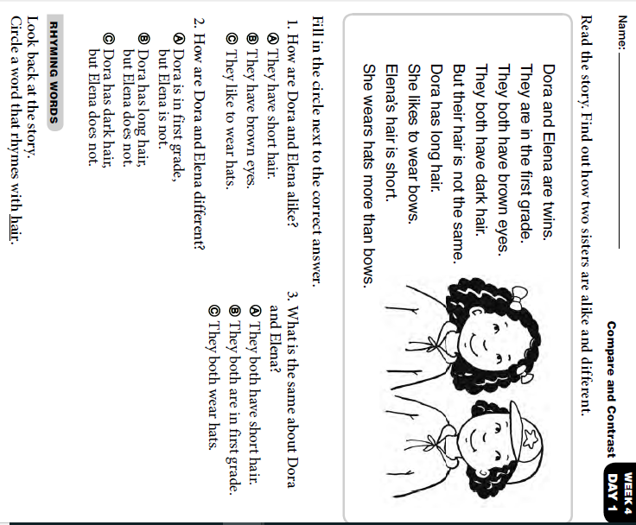
Monday- Skills
Tuesday Activity Schedule
- Check It Off When Completed | Activity
 | Morning Work
 | Reading Comprehension Worksheet
 | Independent reading 20 minutes
 | Book Story Map
 | 25 minutes of Lexia or RazKids
 | Math Worksheet
 | 30 minutes of SplashMath or Zearn
 | Skills Worksheet
 | *Choice activity time: pick an activity from the ClassDojo class story (watch a read aloud, try a learning website, or reading journal entry) or independent read for 20 minutes

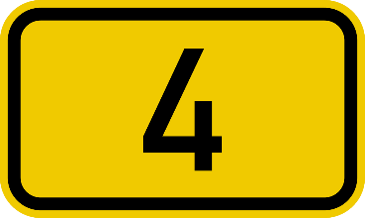
Morning Work- Tuesday

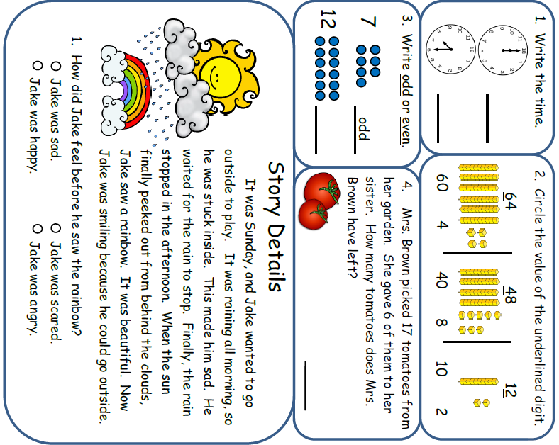

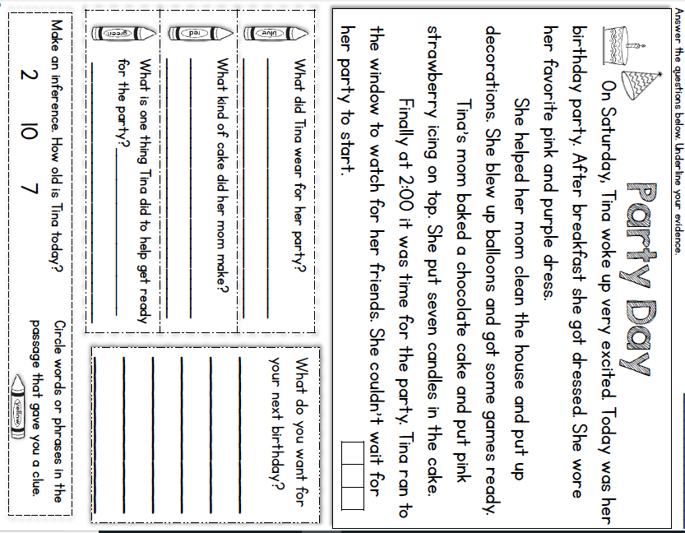
Tuesday- Reading

Tuesday- Reading
Read a book and complete this story map
Tuesday- Reading

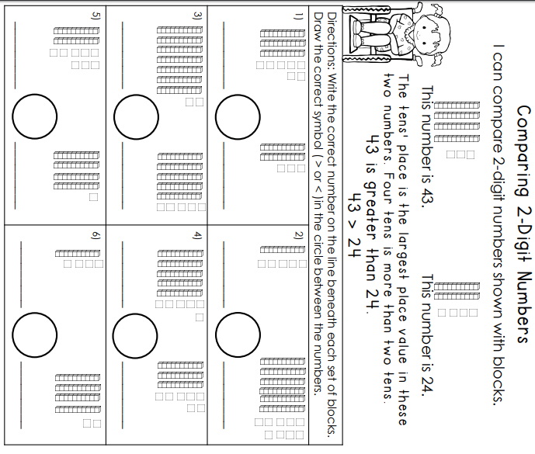
Tuesday- Math
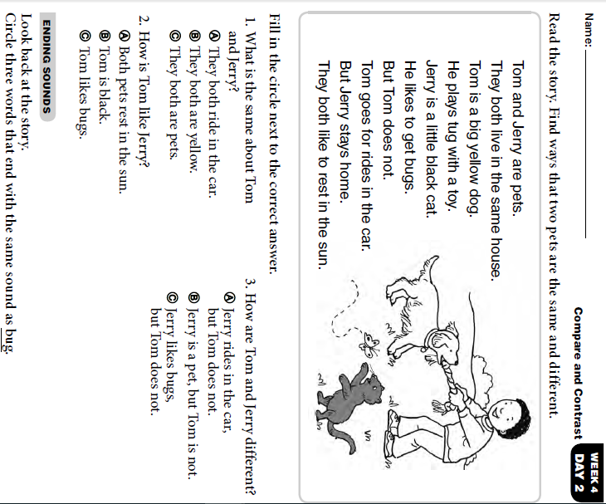
Tuesday- Skills

Wednesday Activity Schedule
- Check It Off When Completed | Activity
 | Morning Work
 | Writing a story
 | Independent Reading 20 minutes
 | Reading Comprehension Worksheet
 | 40 minutes of Lexia or RazKids
 | Math Worksheet
 | 40 minutes of SplashMath or Zearn
 | Skills Worksheet
 | *Choice activity time: pick an activity from the ClassDojo class story (watch a read aloud, try a learning website, or reading journal entry) or independent read for 20 minutes
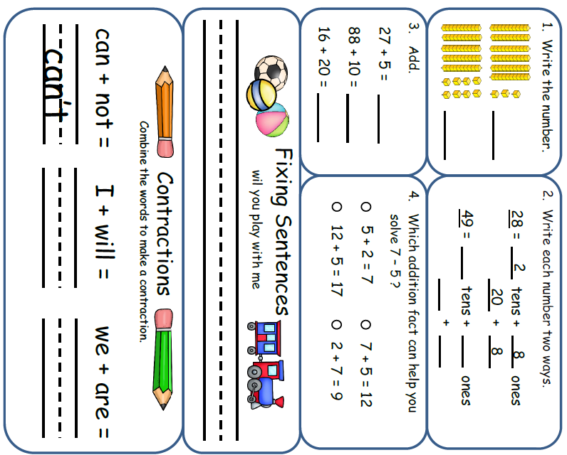
Morning Work- Wednesday
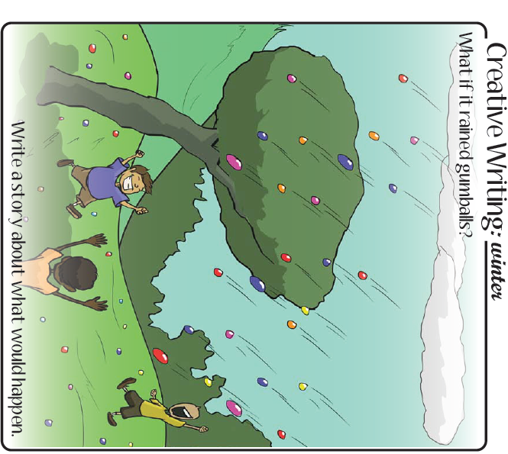

___________________________________________________________________________________________________________________________________________________________________________________________________________________________________________________________________________________________________________________________________________________________________________________________________________________________________________________________________________________________
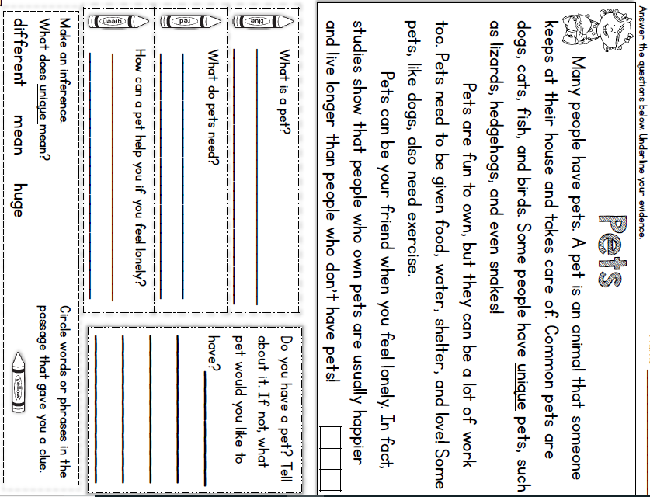
Wednesday - Reading

Wednesday- Math

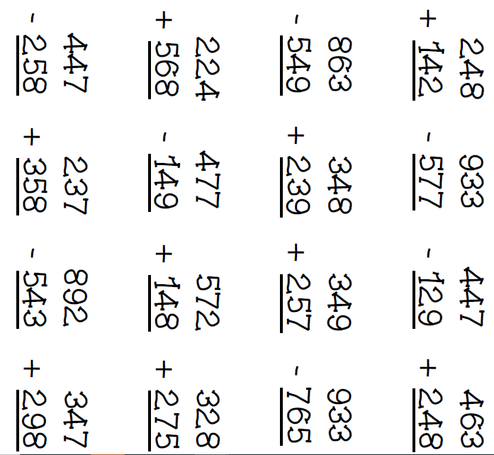
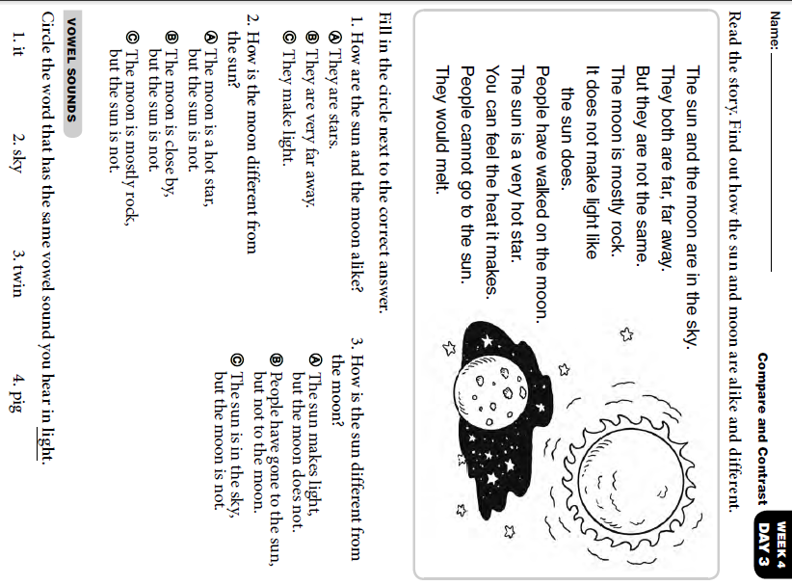
Wednesday- Skills

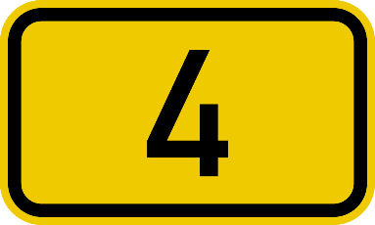

Thursday Activity Schedule
- Check It Off When Completed | Activity
 | Morning Work
 | Writing a story
 | Reading Comprehension Worksheet
 | Independent Reading 20 Minutes
 | Book story map
 | 30 minutes of Lexia or RazKids
 | Math Worksheet
 | 30 minutes of SplashMath or Zearn
 | Skills Worksheet
 | *Choice activity time: pick an activity from the ClassDojo class story (watch a read aloud, try a learning website, or reading journal entry) or independent read for 20 minutes

Morning Work- Thursday
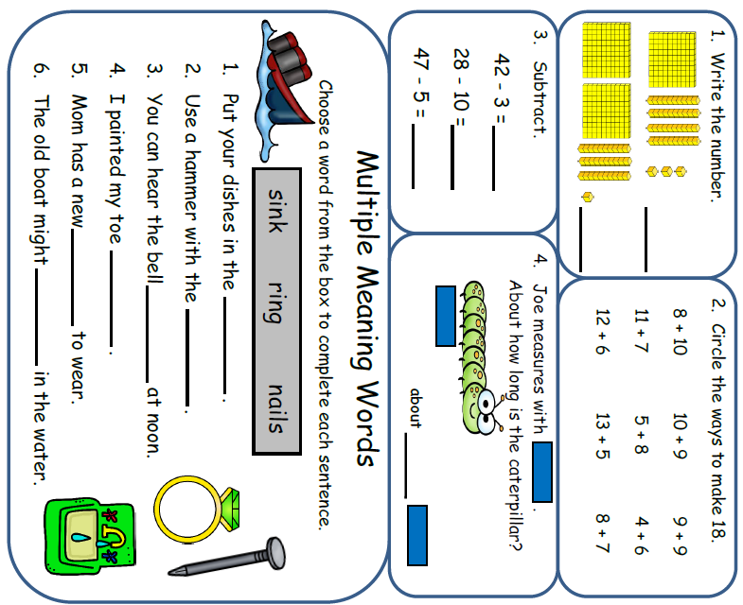


Words to use:
- squirrel
- sneaky
- peanut butter cup
- hungry

_______________________________________________________________________________________________________________________________________________________________________________________________________________________________________________________________________________________________________________________________________________________________________________________________________________________________________________________________________________________________________________________________________________________________________________
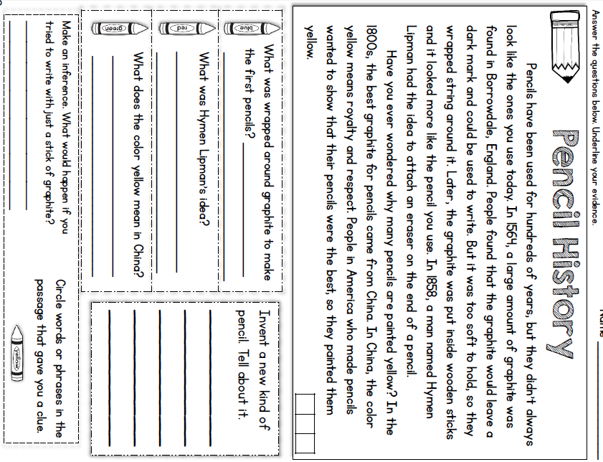
Thursday- Reading

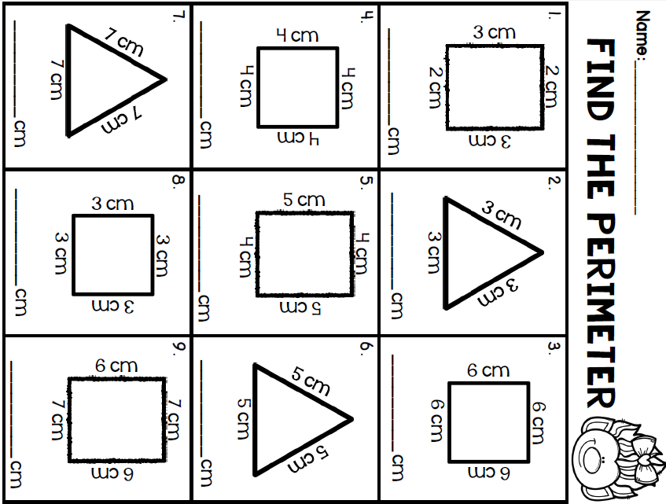
Add all sides together!
Thursday- Math

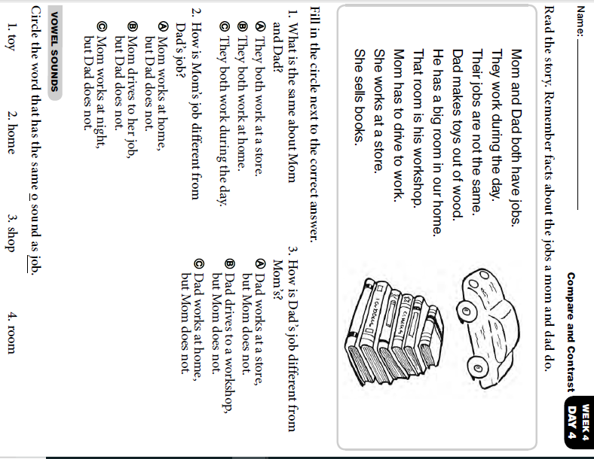
Thursday Skills

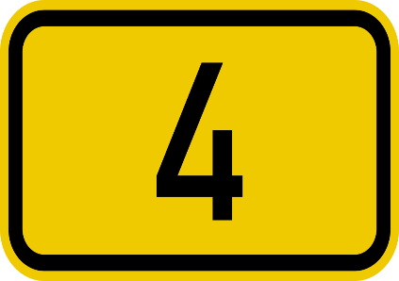

Friday Activity Schedule
- Check It Off When Completed | Activity
 | Morning Work
 | Writing a story
 | Independent reading 20 minutes
 | Reading Comprehension page
 | 40 minutes of Lexia or RazKids
 | Math Worksheet
 | 40 minutes of SplashMath or Zearn
 | Skills Worksheet
 | *Choice activity time: pick an activity from the ClassDojo class story (watch a read aloud, try a learning website, or reading journal entry) or independent read for 20 minutes

Morning Work- Friday

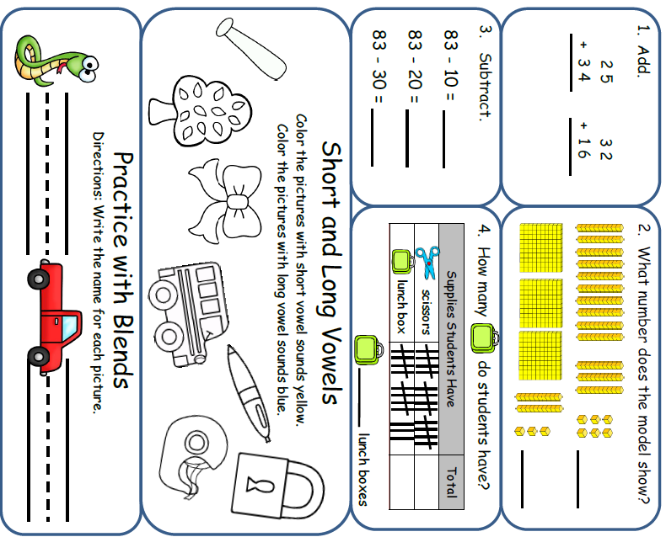


Words to use:
- giraffe
- tree
- climb
- scared

_______________________________________________________________________________________________________________________________________________________________________________________________________________________________________________________________________________________________________________________________________________________________________________________________________________________________________________________________________________________________________________________________________________________________________________
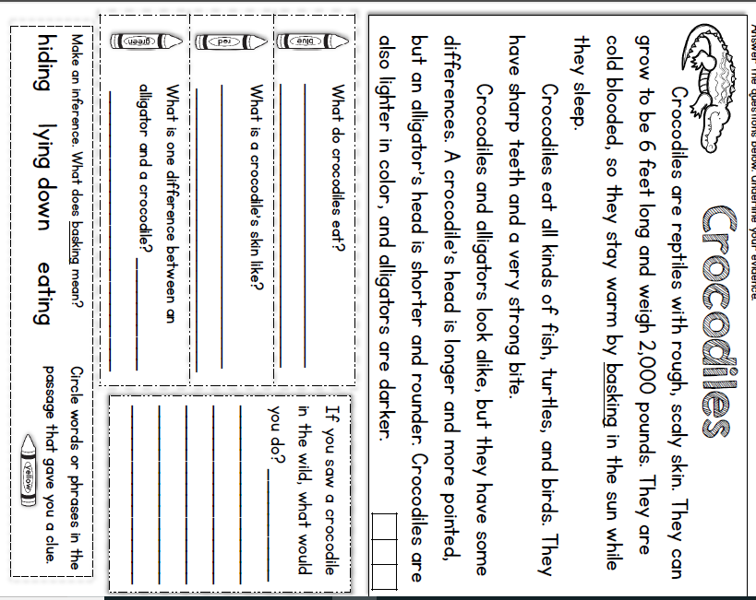
Friday Reading

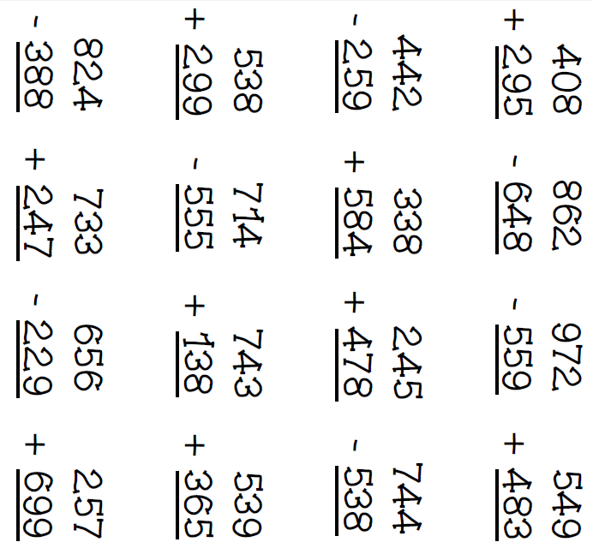
Friday Math

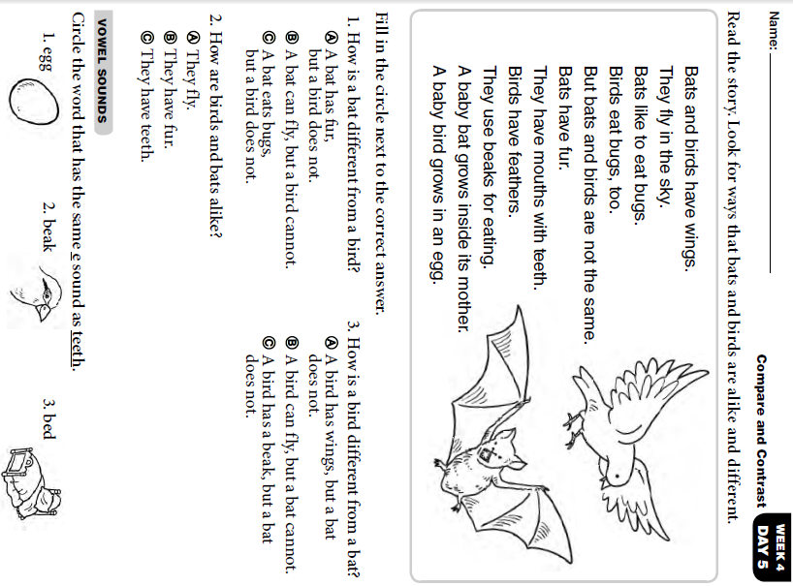
Friday Skills

Monday Activity Schedule
- Check It Off When Completed | Activity
 | Morning Work
 | Reading Comprehension Worksheet
 | Independent reading 20 minutes
 | Book Story Map
 | 25 minutes of Lexia or RazKids
 | Math Worksheet
 | 30 minutes of SplashMath or Zearn
 | Skills Worksheet
 | *Choice activity time: pick an activity from the ClassDojo class story (watch a read aloud, try a learning website, or reading journal entry) or independent read for 20 minutes
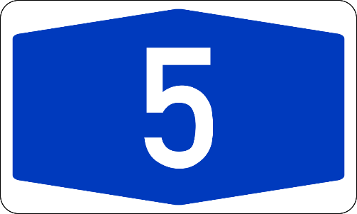
Morning Work- Monday
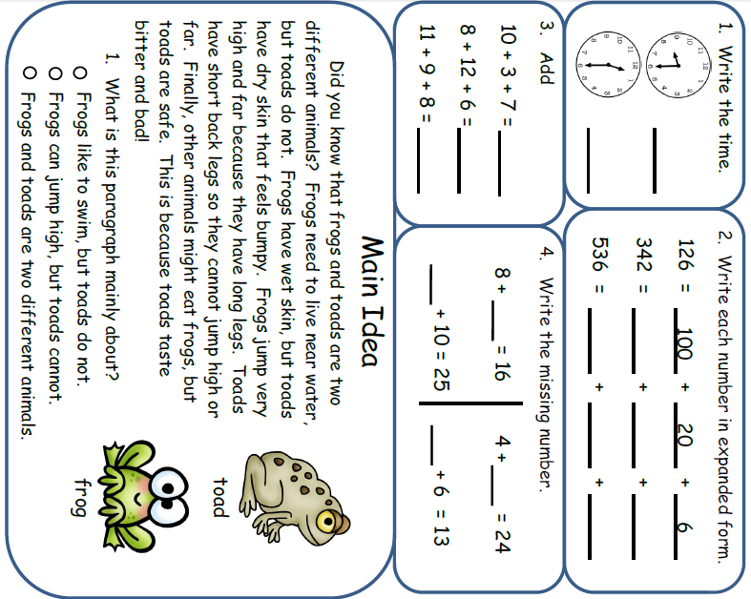

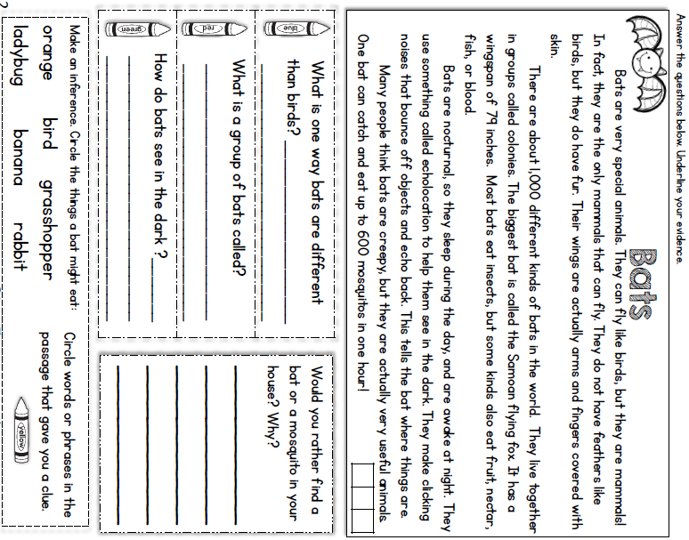
Monday- Reading

* Read a book and complete this story map.****
Monday- Reading
Monday- Math
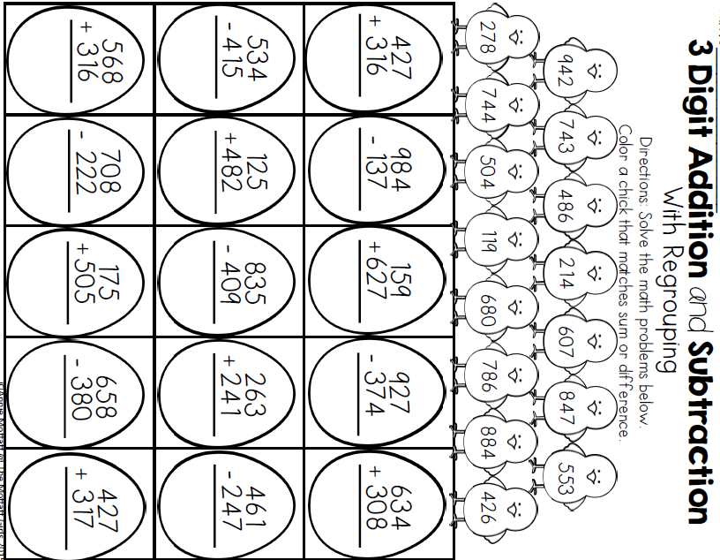
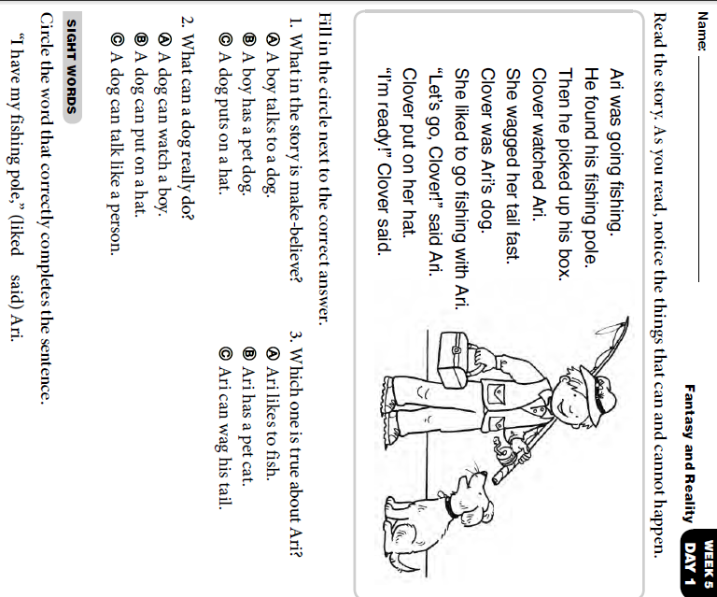
Monday- Skills
Tuesday Activity Schedule
- Check It Off When Completed | Activity
 | Morning Work
 | Writing a story Worksheet
 | Reading Comprehension
 | Independent reading 20 minutes & Book Story Map
 | 25 minutes of Lexia or RazKids
 | Math Worksheet
 | 30 minutes of SplashMath or Zearn
 | Skills Worksheet
 | *Choice activity time: pick an activity from the ClassDojo class story (watch a read aloud, try a learning website, or reading journal entry) or independent read for 20 minutes
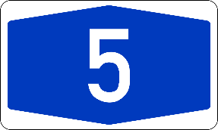
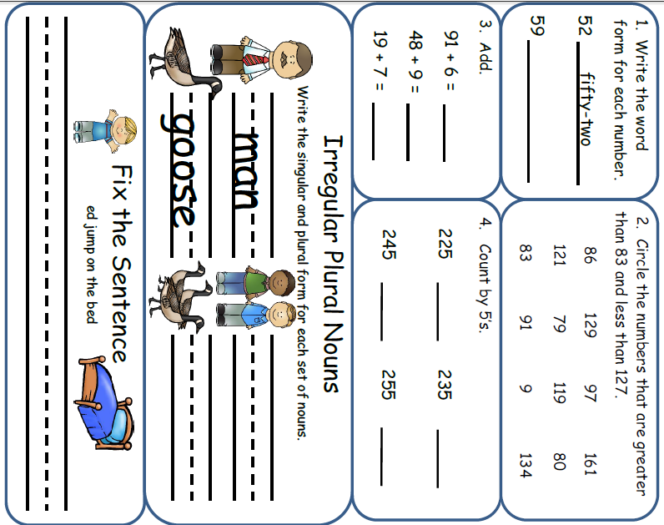
Morning Work- Tuesday

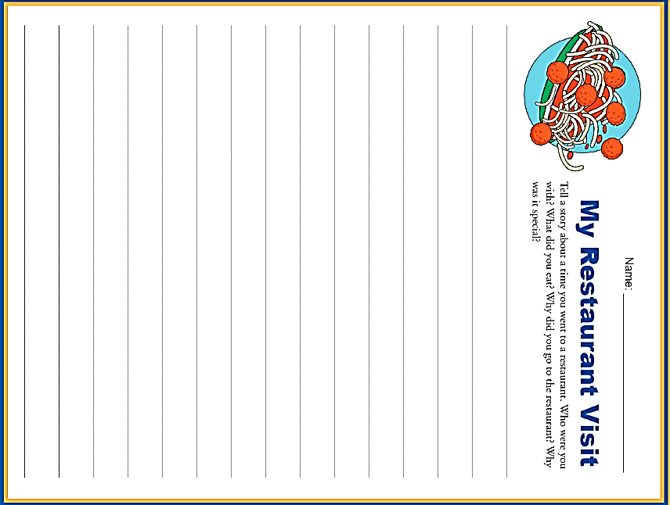

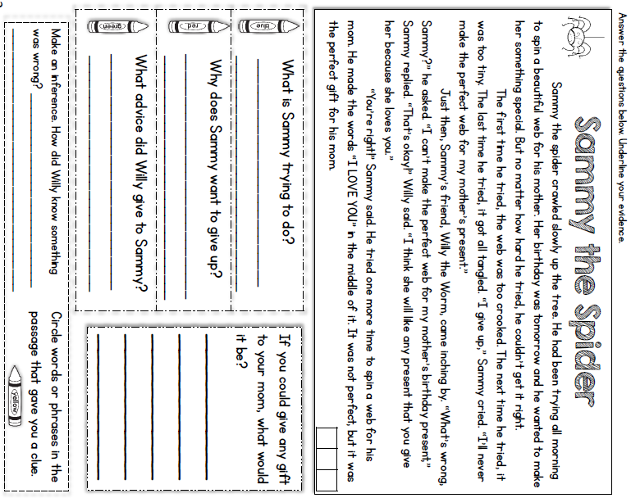
Tuesday- Reading

Read a book and complete this story map
Tuesday- Reading

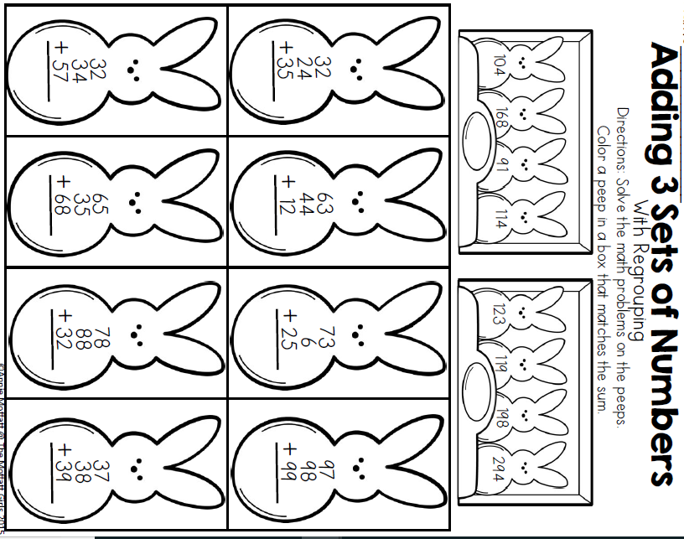
Tuesday- Math
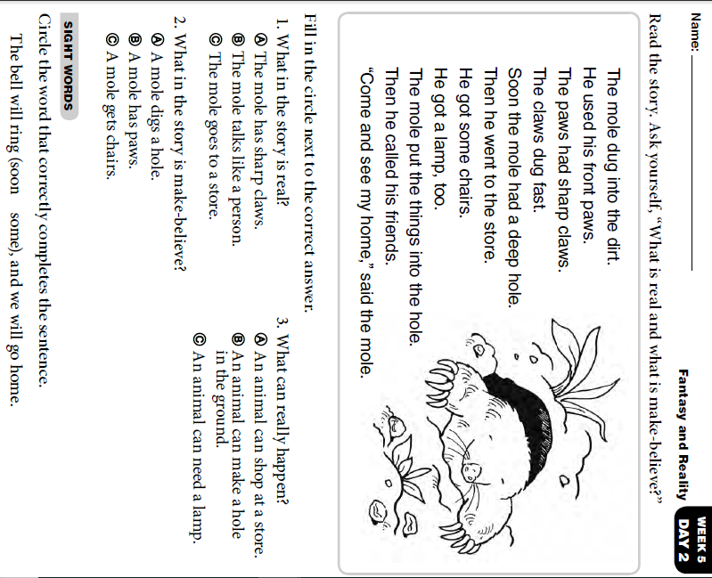
Tuesday- Skills

Wednesday Activity Schedule
- Check It Off When Completed | Activity
 | Morning Work
 | Writing a story
 | Independent Reading 20 minutes
 | Reading Comprehension Worksheet
 | 40 minutes of Lexia or RazKids
 | Math Worksheet
 | 40 minutes of SplashMath or Zearn
 | Skills Worksheet
 | *Choice activity time: pick an activity from the ClassDojo class story (watch a read aloud, try a learning website, or reading journal entry) or independent read for 20 minutes
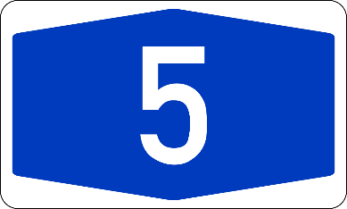
Morning Work- Wednesday
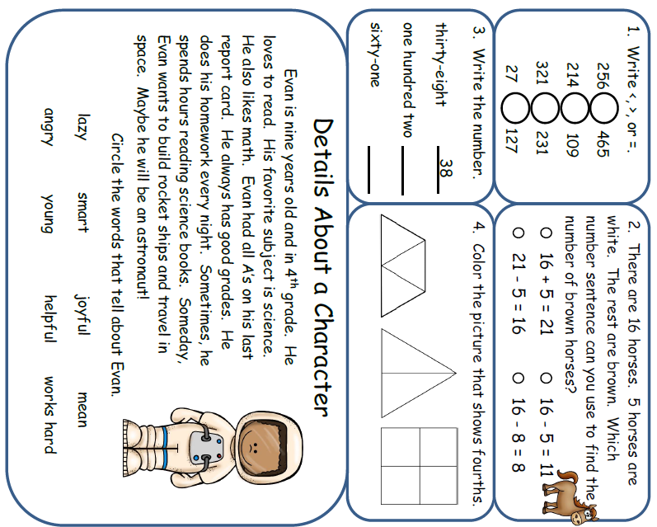

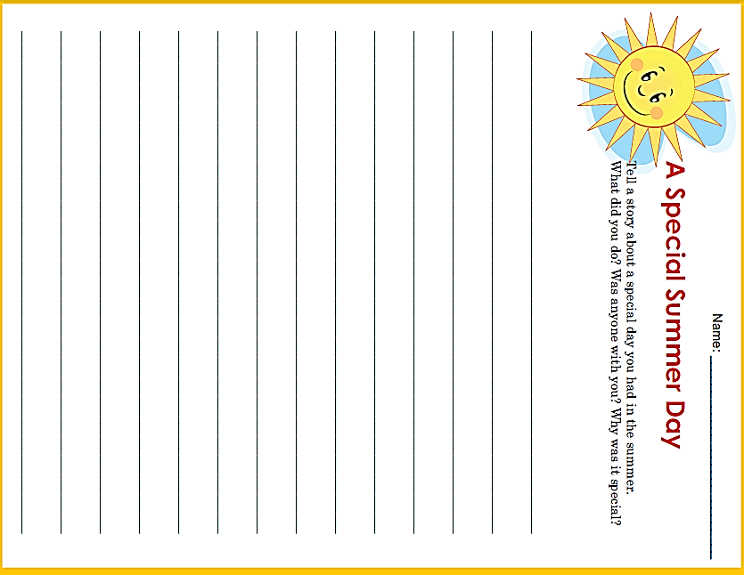

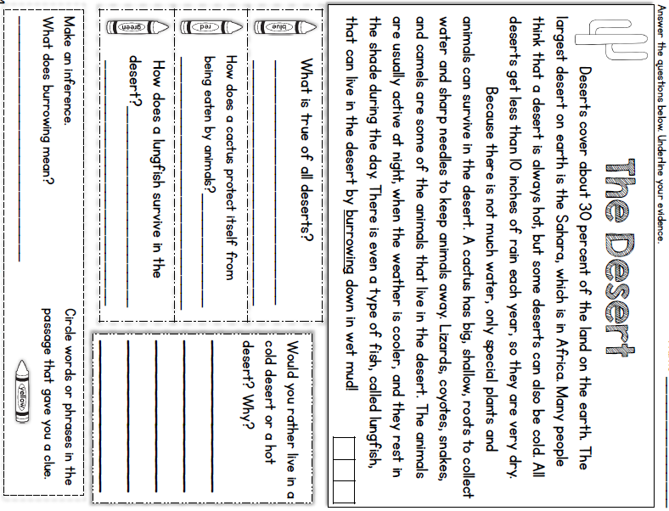
Wednesday - Reading

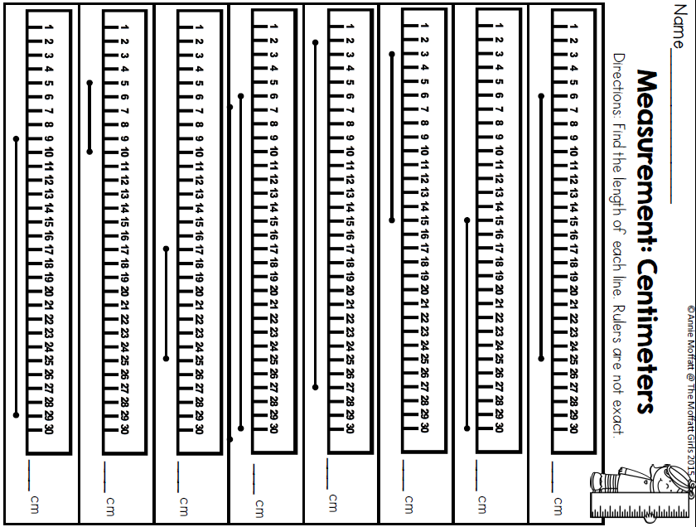
Wednesday- Math

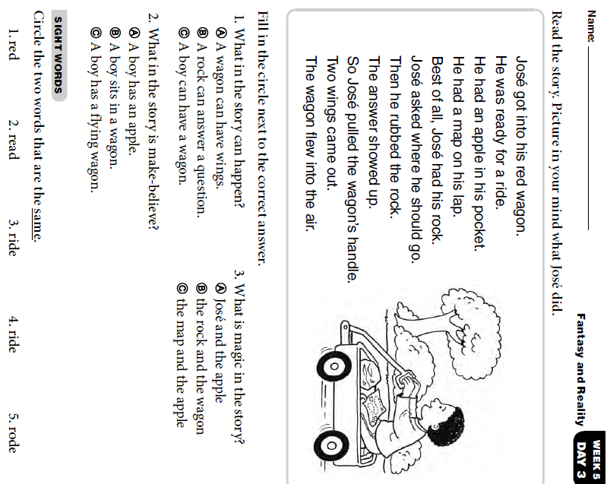
Wednesday- Skills

Thursday Activity Schedule
- Check It Off When Completed | Activity
 | Morning Work
 | Reading Comprehension Worksheet
 | Independent Reading 20 Minutes
 | Book story map
 | 30 minutes of Lexia or RazKids
 | Math Worksheet
 | 30 minutes of SplashMath or Zearn
 | Skills Worksheet
 | *Choice activity time: pick an activity from the ClassDojo class story (watch a read aloud, try a learning website, or reading journal entry) or independent read for 20 minutes

Morning Work- Thursday

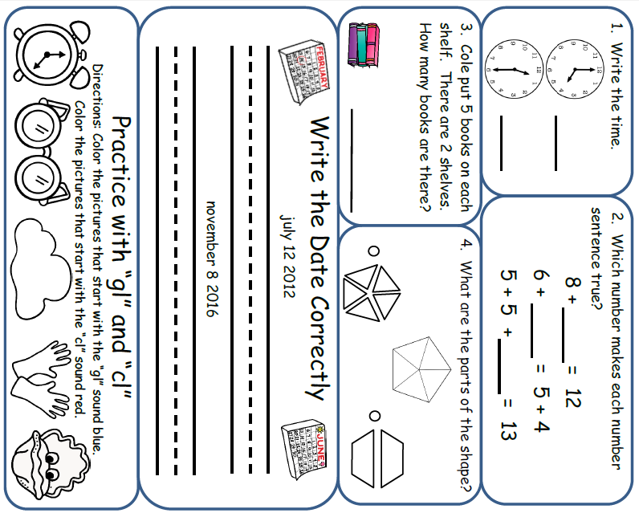

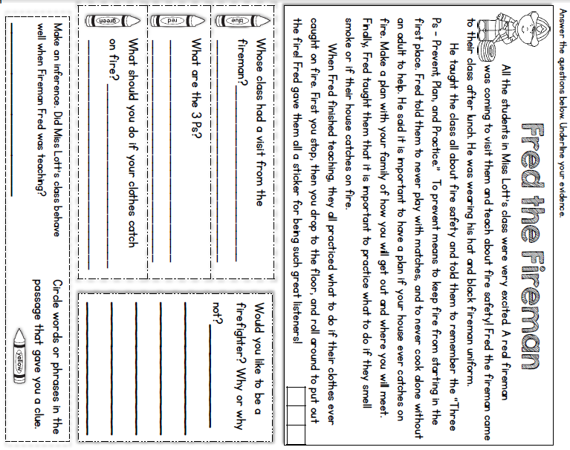
Thursday- Reading

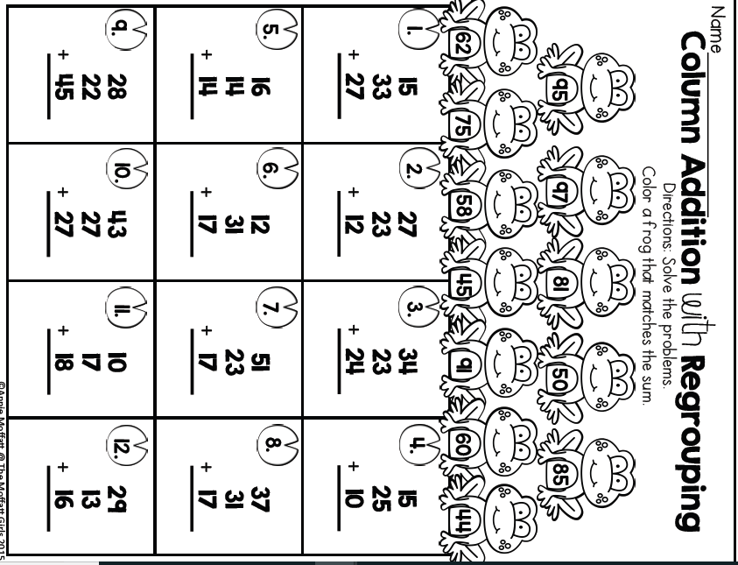
Thursday- Math

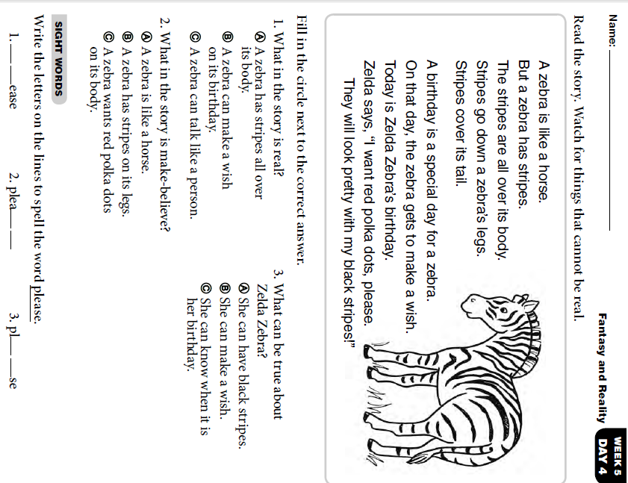
Thursday Skills

Friday Activity Schedule
- Check It Off When Completed | Activity
 | Morning Work
 | Writing a story
 | Independent reading 20 minutes
 | Reading Comprehension page
 | 40 minutes of Lexia or RazKids
 | Math Worksheet
 | 40 minutes of SplashMath or Zearn
 | Skills Worksheet
 | *Choice activity time: pick an activity from the ClassDojo class story (watch a read aloud, try a learning website, or reading journal entry) or independent read for 20 minutes

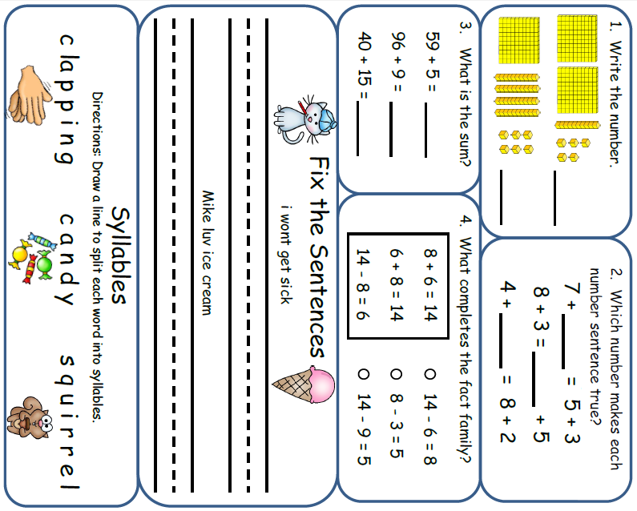
Morning Work- Friday
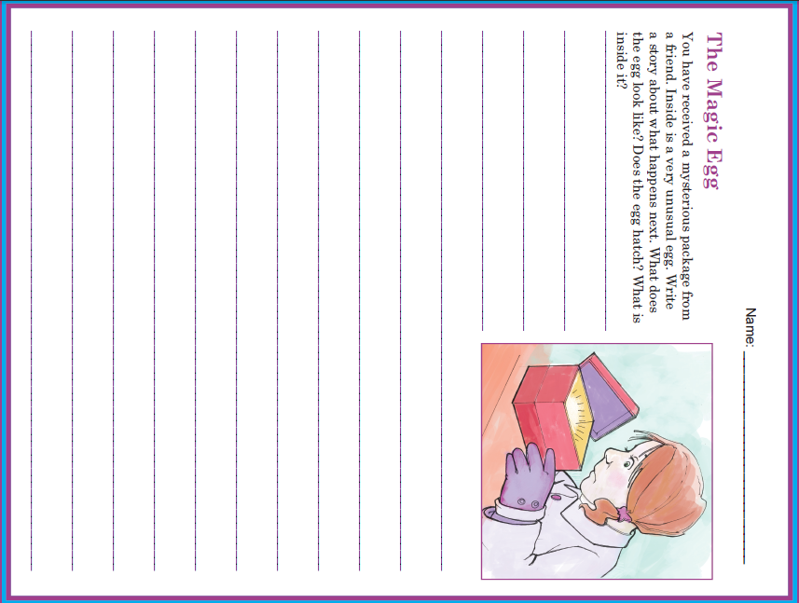

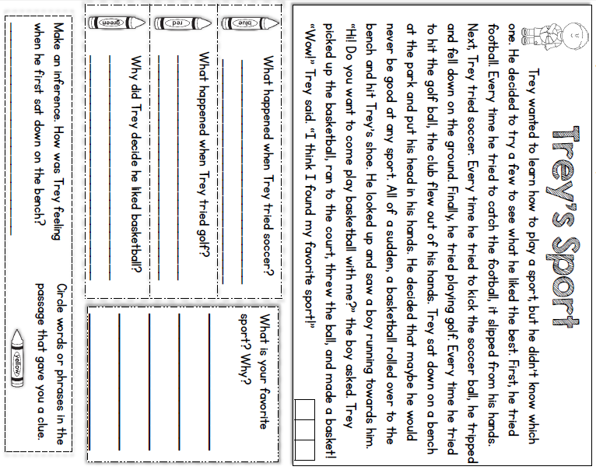
Friday Reading

Friday Math

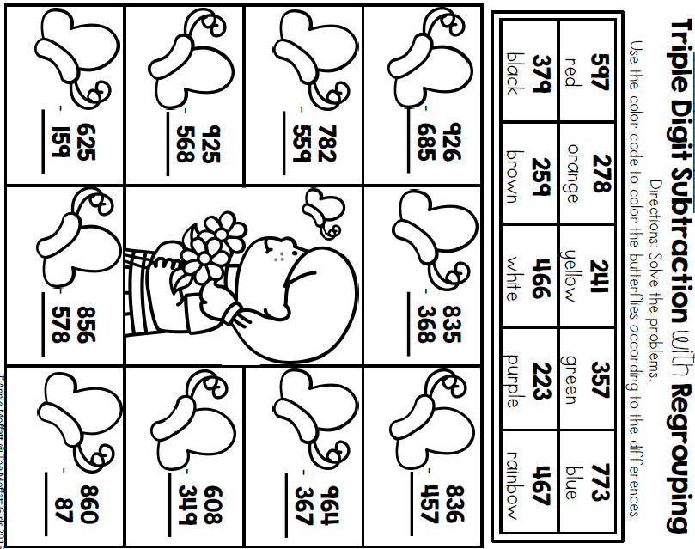

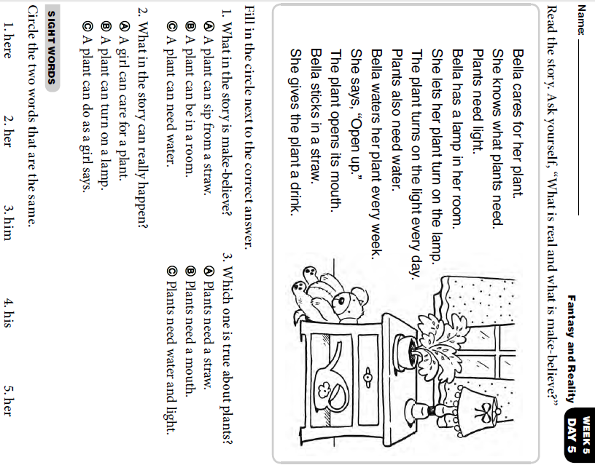
Friday Skills

